Workshop Bodenburg
Water
Headed by:
Prof. Gero Canzler
Participants:
Dieter Berkei
Kim Meyer-Bruhns
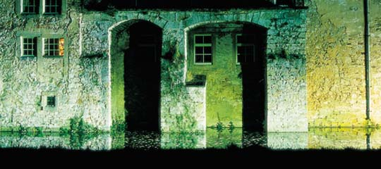
Due to the way it reflects and transmits light, water is a very special material to be used in combination with light. Materials in the water, including the river bed have an influence on colour and bright-ness. The group worked exclusively with light on water.
Water is part of our natural surroundings. Its surface is flexible, a feature that takes some getting used to.
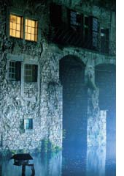
The water's surface also includes the peripheral areas. The most important area for this group was the facade of the castle. This was not illuminated directly, only the surface of the water in the moat. The facade comprised a bright area in the otherwise dark park. The group decided to use a combina-tion of light source and water surface as a secondary reflector. Just as a face can look brighter if the person is bent over illuminated writing paper, so the castle façade was lightened by the reflections in the water. A blue filter was applied to a small staircase window located low in the facade and illuminated from behind. This frequently applied lighting detail is especially attractive when seen in contrast to the background setting.
The water surface near the warm white spotlights was especially bright. The surrounding pitch black thicket provided an especially harsh contrast, so it was decided to uplight this area of vegetation in a discreet blue.
A clump of reeds received light from IP 68 spotlights, some of which were positioned under the water and some on the bank of the moat.
An artistic touch was provided by the group in the form of a snake-like sculpture consisting of one optical fibre. The projector was positioned in the park a little way from the moat with the wavy line of light ending in the water next to the reeds. Each of the areas treated had to be marked by a boundary. The moat ends at a retaining wall, in front of which there is a tree. This also forms the border to the private park of the park, which is not lit.
Two effects were now missing in the overall ensemble: differentiated lighting and depth.
The idea was developed to work with effects and symbols: the tree was regarded as a living form and uplit by two spotlights with tungsten halogen lamps, one without a filter (warm white) and one with an orange filter. The retaining wall was illuminated diagonally from below by luminaires equipped with blue metal halide lamps. Concentrated yellow-red light in front of a blue surface awakens a sense of man's first experience with light: the yellow sun in a blue sky.

